Customizing and creating new mini-lesson files

Table of Contents

Overview 2

S3 file structure reminder 2

Editing and previewing existing mini-lesson files 2

Adding a mini-lesson file 4

Adding a new track to an existing mini-lesson 4

Creating a new mini-lesson (modulette) 5

Creating a new file 5

File naming conventions 7

Working with authoring templates 7

Authoring template basics 8

Commonly used authoring terms 10

Authoring template functionality 11

Adding and editing tables 13

Creating a new table manually 13

Icons and styles 17

Adding icons 18

JUICE styles and how to apply them 19

Authoring for accessibility 21

Using the “Screen Reader only” style effectively 22

Guided Practice specific features 22

Adding interactions to Guided Practices 24

Creating new challenge game files 26

Game authoring templates 26

# Overview

Mini-lesson files (Overviews, Try its, Challenge games) contain the content that is displayed by the JUICE widgets (content players) when a student clicks on a track in a JUICE modulette (mini-lesson). Mini-lesson files are .json formatted text files that are stored in each modulette’s directory in S3.

You can use authoring templates provided by the JUICE site to edit existing mini-lesson files.

You can also create new mini-lesson files and remove files that you don’t want, as long as you also make the necessary edits to the modulette files as described in the documentation *Customizing a JUICE mini-lesson*.

## S3 file structure reminder

Module and modulette ids correspond to directory names in S3. For example,

* The files for module QS1 are found in the S3 directory QS1
* The files for modulette QS1.1 re found in the S3 directory QS1/1

Files for alternate (custom) programs are found in the specific alternate program’s directory, which is located in /programs.

Note that S3 uses the forward slash (/) for path names rather than the DOS backslash (\).

# Editing and previewing existing mini-lesson files

If you have uploaded the JUICE content to Amazon S3, you may use one of the JUICE site’s 13 different authoring templates to edit Refresher (Overview), Guided Practice (Try it), and Challenge (Challenge games) files. You open the files in the correct template, make changes, and save. You can preview your changes in a similar manner.

Note: Your AWS key and secret must be set in the site code’s local.json file for you to use these editing tools.

In this document, the section on *Working with Refresher and Guided Practice authoring templates* provides a basic introduction to using the Refresher and Guided Practice authoring templates. Additional information is located in the documentation directory called **Content Authoring_overview, tryit, games.**

To edit and preview mini-lesson files, access the content authoring and previewing templates as follows:

1. Access the test log-in page for your instance of JUICE at /juice/oauth_test
2. Choose a user with a role of Admin and click Submit.
3. In the new JUICE tab, open the correct file authoring template by putting this URL into your browser:

/juice/author/[widget type]/[module].[modulette].[S3 filename]

Example:

/juice/author/refresher_widget/CS17.1.Refresher_Generating_ideas

See below for information about determining the widget type.

1. To **preview** your changes, first **SAVE** them. The file will be saved to the S3 bucket that you have defined as your dev bucket in juice.js.
2. Use this URL to preview the file:

/juice/preview/[widget type]/[module].[modulette].[S3 filename]

Example:

/juice/preview/refresher_widget/CS17.1.Refresher_Generating_ideas

IMPORTANT! The widget type in the URL MUST specify the correct widget! Otherwise, you can damage your file. There is NO PROTECTION against this!

To decide what widget type to use in the URL, look at the mini-lesson file name and then choose the correct widget type from the table below.

If the file is a challenge wheel file, the widget type will not be listed. In this case, play the game in the site to see which type of game it is.

Any other game file without a widget type is a test file, and should be removed from your S3 instance.

Widget type table:

| If the filename includes this: | The widget type is this: |
| --- | --- |
| Refresher | refresher_widget |
| GuidedPractice | guided_practice_widget |
| balancer | balancer_widget |
| quickpick | quick_pick_widget |
| sorter | sorter_widget |
| puzzler | puzzler_widget |
| fridgemagnets | fridge_magnets_widget |
| finderskeepers | finders_keepers_widget |
| pickandstack | pick_and_stack_widget |
| stacker | stacker_widget |
| perfectword | perfect_word_widget |
| highlighter or spotlight | highlighter_widget |
| fixit | fix_it_widget |

# Adding a mini-lesson file

There are two different use cases for adding a new mini-lesson file:

1. You want to add a track to an existing modulette’s tab.
2. You are creating a new modulette (mini-lesson) in an existing module or new module.

Note: JUICE does not support having more than one mini-lesson file for an existing track.

In each case, the basic steps are as follows:

1. Create directories in S3 as needed, reviewing the documentation on *Customizing a JUICE module* and *Customizing a JUICE mini-lesson* as needed.
2. Create the new file
3. Update or create new **modulette.txt**, **module.txt**, and **modules.txt** files to reference the new mini-lesson.
4. Add the mini-lesson to the Mongo DB Search tables. See the document *Using tags to improve JUICE Search* for more information about updating Search.

## Adding a new track to an existing mini-lesson

To add a new track and file to an existing mini-lesson, create the mini-lesson file as described below, and then update the existing mini-lesson’s **modulette.txt** file to include information about the new track and file as described in *Customizing a JUICE mini-lesson*.

Track information in a modulette.txt file:

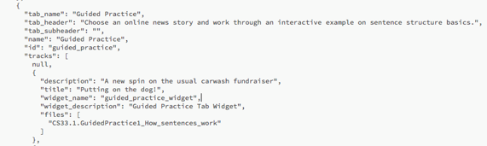

## Creating a new mini-lesson (modulette)

When you create a mini-lesson file for a new mini-lesson, you must also create the S3 directories in which the file will be stored. The type and number of directories that you need depends on whether the mini-lesson file is for a mini-lesson being added to an existing module, or to a new module.

If the file is for a mini-lesson being added to a new module, create a new module directory folder in your main program folder, then create a new modulette directory folder inside of that.

If you’re creating a new mini-lesson for an existing module, you only need to create a new modulette folder inside of that existing module.

Create your file, and then add the file information to **modulette.txt**, **module.txt**, and **modules.txt** as needed, and add the mini-lesson to the Mongo DB Search tables. See the document *Using tags to improve JUICE Search* for more information about updating Search.

## Creating a new file

Load the authoring template to create a new file as follows:

1. Access the test log-in page for your instance of JUICE at /juice/oauth_test
2. Choose a user with a role of Admin and click Submit.
3. In the new JUICE tab, open the correct file authoring template by putting this URL into your browser:

/juice/author/[widget type]/-

Example:

/juice/author/refresher_widget/-

The hyphen in the URL will load a blank authoring template for a refresher widget.

If you want to create a new guided practice or game file, follow the same steps except replace “refresher_widget” in the URL with “guided_practice_widget” or one of the game widget types such as “sorter_widget”.

| Possible widget types: |
| --- |
| refresher_widget |
| guided_practice_widget |
| balancer_widget |
| quick_pick_widget |
| sorter_widget |
| puzzler_widget |
| fridge_magnets_widget |
| finders_keepers_widget |
| pick_and_stack_widget |
| stacker_widget |
| perfect_word_widget |
| highlighter_widget |
| fix_it_widget |

1. Save your new file before you start editing it to ensure that a new file is created in S3.  
   1. Click Save
   2. Ignore the default text in the Save dialog box. Instead, enter a file name in this form:

S3 directory path/name

For core JUICE, the S3 directory path should be in the form **module id/modulette number**

Example:

D1/1/Refresher_sample file

If you are creating a file in an alternate program, the directory path should include the program information.

Example:

programs/chris3/D1.1.Refresher_sample file

* 1. Click OK

Note: The complete “file name” for this new file will be the S3 directory path and name transformed by replacing the / with periods (.), and spaces with underscores.

You entered this for saving: D1/1/Refresher_sample file

The file name is now this: D1.1.Refresher_sample_file

If you look in the S3 directory D1/1, your file will show as **Refresher_sample_file.txt**.

1. Before you continue authoring, load your new file from its saved location. Replace the hyphen in the URL with the new file’s file name.

Example:

Instead of /juice/author/refresher_widget/-

Use this /juice/author/refresher_widget/D1.1.Refresher_sample_file

1. Use the features of the template to add content to your new file!
2. When you want to preview what you have done, SAVE the file, and and then use this URL to preview it:

/juice/preview/[widget type]/file name

Example:

/juice/preview/refresher_widget/D1.1.Refresher_sample_file

## File naming conventions

If you have already specified a file name in the **modulette.txt** file, your new file’s name should match. It should follow this form:

[module ID].[Modulette ID].[ Widget type and track #]_[skill name]

Example:

D1.1.GuidedPractice1_Adding_fractions

This file uses a guided practice widget for track 1, and the skill is Adding fractions.

If your file is in an alternate program, its name should include the program directory information:

programs.chris3.D1.1.Challenge1_Subracting_decimals

Suggested widget type names:

Overview Refresher

Try it GuidedPractice

Any game Challenge

# Working with authoring templates

This section covers the basic features and functionality of the Refresher and Guided Practice authoring templates. The documentation directory called **Content Authoring_overview, tryit, games** includes additional authoring information:

* More details on the Refresher template
* How to create guided practice interactions
* Instructions for the game templates
* JUICE language and formatting conventions
* Creating images
* Best practices for accessibility
* and more!

## Authoring template basics

Once you enter the URL, the authoring template for the widget will load. The templates for Refreshers and Guided Practices look nearly identical, except for some additional tools that are available for guided practices.

The example images presented in the descriptions below are taken from a Refresher file. However, the descriptions and instructions apply to both Refresher and Guided Practice files, and you will be able to find these editing tools in the same location in the template for both file types.

When you open a refresher or guided practice authoring template, you will see something like this:

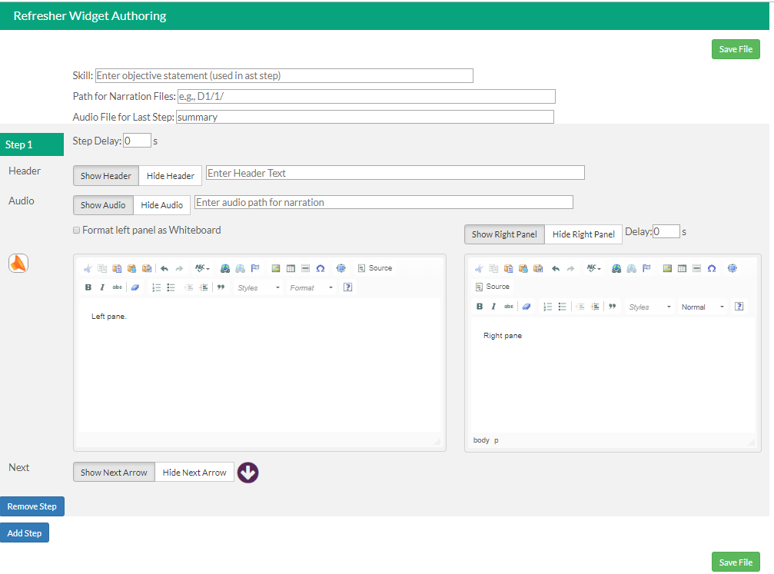

## Commonly used authoring terms

Before editing your file, refer to the table below for definitions of commonly used terms in JUICE mini-lesson authoring.

|  |  |
| --- | --- |
| Term | Explanation |
| Part | Group of steps covering the same idea. These steps should play automatically, only the last step in a part should have the “next arrow” displayed. |
| Part header | White text on a colored background that appears at the beginning of the part. This is authored as part of the step that follows it. |
| Step | A row of text that plays within a part. Steps can have two columns or one column. If the step has two columns, the right column will have a “whiteboard” panel. If it is one column, the text will span across the full width of the step. |
| Next arrow | Arrow that allows students to “play” the next step. When a step has a next arrow, the step that follows it will not play until the arrow is clicked. Use next arrows at the end of parts |
| Auto follow | This is what happens when a step has no next arrow. The next step “auto follows” the step preceding it. |
| Delay | How long a step will wait to play after the previous step is complete. Delay is defined in seconds and can be 0 (no delay). Delay is also available for the right panel and says how long the right panel should wait to display after the left panel loads.  The delay between steps is typically used when there is no audio. If there is audio, the next step will not play until the audio is complete. The right panel does NOT pay attention to audio. |

Authoring template functionality

This is the top of the authoring template. Use these fields to define where the mini-lesson file will pull audio narration files from.

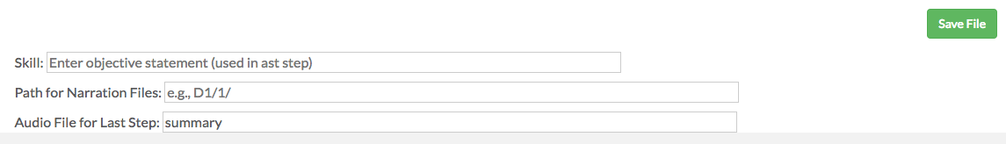

**Skill** - not currently used

**Audio file for last step** – Audio file name for last step in the widget. Leave set to “summary”

**Path for narration files** tells the Refresher where to find the narration files

The next section contains the controls for an individual step:

**Show/Hide Header & Header text** – Creates a part header at the top of step. You can define the text that will appear

**Step delay** – how long the step will wait to play AFTER the previous step is complete.

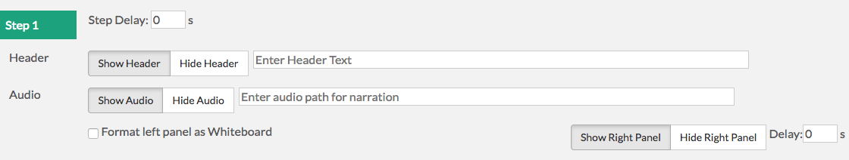

**Show/Hide Right Panel** – Hides the whiteboard. If the whiteboard is hidden, text in the left column will span both columns

**Format left panel as Whiteboard** – Displays the left panel text as purple on a white background.

**Show/Hide Audio & Audio path** – see *8_Adding and customizing narration*

Beneath the step controls are the text fields where you can write and edit your content. We refer to these areas as the left and right panels or panes:

**Source button** – Clicking shows the underlying HTML source code. You can edit or add your own code. Functions the same for both panes.

**Icons** – Formatting tools. Each pane has its own set of icons

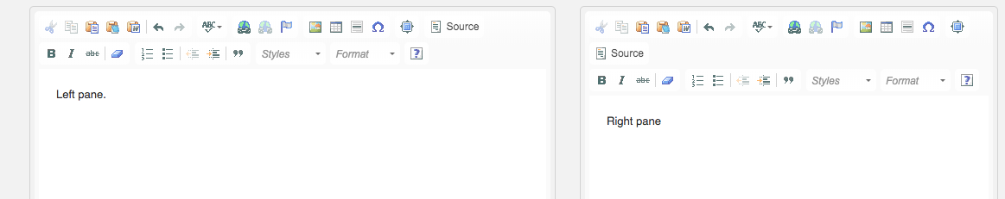

**Styles Menu** – drop-down list of font styles. There are separate drop-down menus for the left and right panels.

Beneath the editing panes are controls for including a next step arrow and inserting or removing a step:

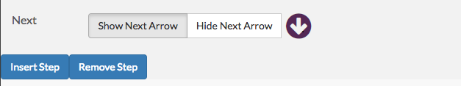

**Show/Hide Next Arrow** – controls whether the student sees the next arrow. If the next arrow is hidden, the NEXT step plays automatically.

**Insert/Remove Step** – Inserting a step will add a step between the current step and the next one. Remove step will delete the current step.

## Adding and editing tables

The Refresher and Guided Practice authoring templates allow you to insert tables into either the right or left panels. JUICE includes a variety of pre-programmed table styles that can be applied.

To view examples of all of JUICE’s tables, login through the JUICE oauth site and access JUICE with the role of Admin. Then enter this URL:

/juice/author/refresher_widget/D1.10.Refresher2_Overview_and_Try_It_test_plan

This will take you to an authoring template containing editable table examples in each of JUICE’s table styles, as well as images of how each table looks in both the left and right panels and on Mac and PC.

You can copy the tables from this template and add them to other Refresher of Guided practice authoring templates as follows:

* + - 1. Click the **Source button** in the panel containing the table you want to copy.
      2. Copy the HTML code beginning at **<table border=** and ending after **</table>** (inclusive).
      3. Click the Source button in the panel that you want to copy into.
      4. Paste
      5. Click Source again to restore the editing view.
      6. Edit your table.

### Creating a new table manually

You can also make a new table from scratch by using the table tool located in the icon bar above the step.

1. Click to place the cursor where you want to make the table appear, then click the table icon above the step.

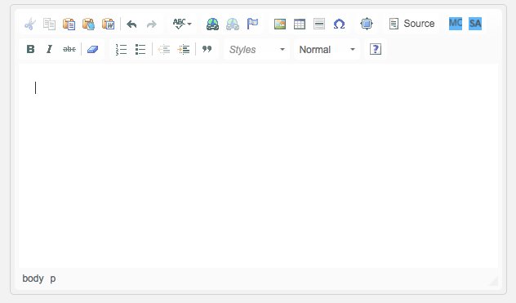

1. This will open the table properties dialog box. Use this to define the number of rows and columns in your table, its height and width as a percentage, whether a row or column should be used as a header, table border size, and the amount of spacing and padding between cells. Values shown in the image below are the default values when the dialog box opens.

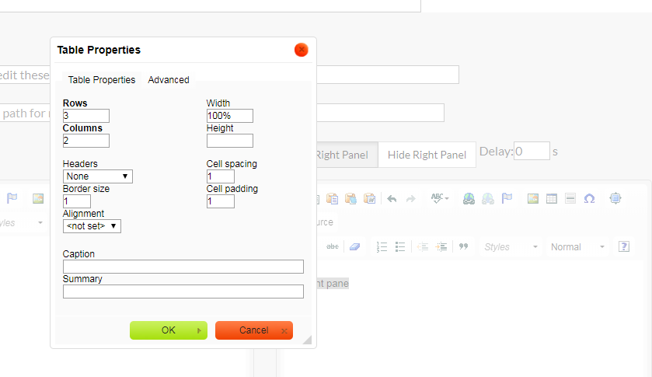

Note: Avoid using table captions. These can be confusing for a screen reader.

1. Clicking the “Advanced” tab of the Table Properties dialog box shows additional formatting options. Enter a value in the **Stylesheet Classes** field to define the JUICE table style.

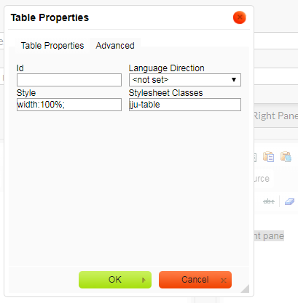

Available table styles are as follows. Each of these specifies the first row as the header row. All of them have border = 0 except where noted.

| Stylesheet Class | How it looks |
| --- | --- |
| ju-table |  |
| ju-tablesmall-pad |  |
| ju-tablesmall |  |
| ju-table ju-tight |  |
| ju-tableplain  Border = 1  This table is transparent. |  |
| ju-tableplain ju-tight  Border = 0  This table is transparent. |  |
| ju-powertip | Used for “Did you know”, “Ask yourself”, and “Careful” tables |
| ju-summary | Used for “Putting it all together” summary tables |

1. After setting the table properties and clicking the “OK” button in the table properties dialog box, your new table will render where the cursor is in the step. You can now edit the contents of the cells. It will not show any of the JUICE styles in the editor.

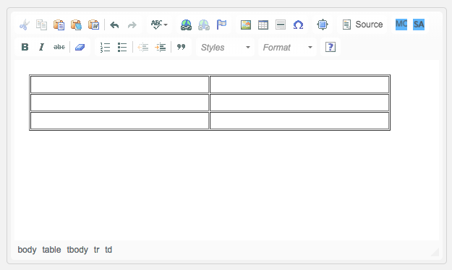

## Icons and styles

JUICE uses a set of icon images and font styles to call attention to links or information and present the various learning content. These icons and styles can be added to any Refresher or Guided Practice.

### Adding Picture it and Accessible image icons

1. Click to place the cursor where you want the icon image to appear, then click the image icon above the step.



1. This will open the Image Properties dialog box. Use this dialog box to define a source URL for the icon image. You can also set the Alternative Text that will be read by screen readers.

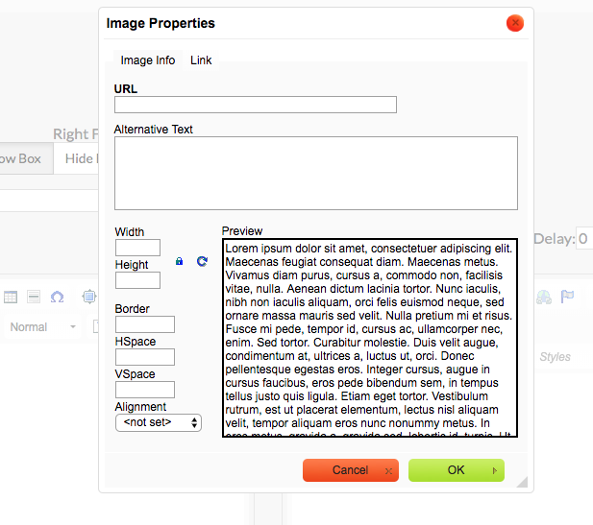

1. Enter the correct URL.   
     
   You can use any URL that links to an image, but JUICE icons are available if you wish to use them.

|  |  |
| --- | --- |
| Icon | How to make it |
| Picture it https://dev.juiceyourskills.com/images/picture_it.png | Enter in URL field: /images/accessible_icon.png |
| Accessible icon https://dev.juiceyourskills.com/images/accessible_icon.png​ | Enter in URL field: /images/accessible_icon.png |

1. Click the “OK” button in the image properties dialog box. Your icon will render where the cursor is in the step.

### Adding incorrect and correct icons

The incorrect and correct icons are created using font styles:

|  |  |
| --- | --- |
| Icon | How to make it |
| Incorrect icon | Put an x in the editor where you want the icon to appear. Highlight the x and choose Orange times from the Styles drop-down menu above the step (The Styles menu will be covered further in the next section). This will be read as “incorrect” by a screen reader. |
| Correct icon | NOTE: DOES NOT USE URL OR IMAGE PROPERTIES  Put a v in the editor where you want the icon to appear. Highlight the v and choose the Green Check style from the styles drop-down menu. This will be read as “correct” by a screen reader. |

### JUICE font styles and how to apply them

JUICE includes a variety of preprogrammed styles that can be applied to text in the editor. To add styles:

1. In the editor, highlight the text to which you want the style applied. Then, click the Styles drop-down menu in the toolbar above the step and select the style you would like to apply.

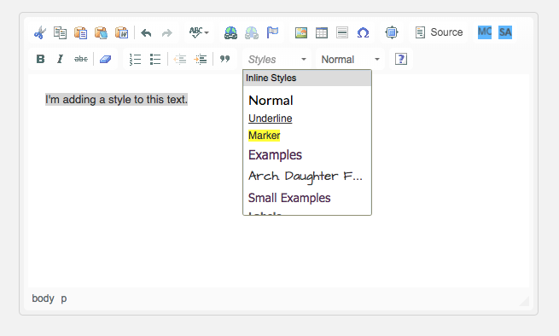

1. The highlighted text will transform into that style as soon as you click an option in the drop-down menu.

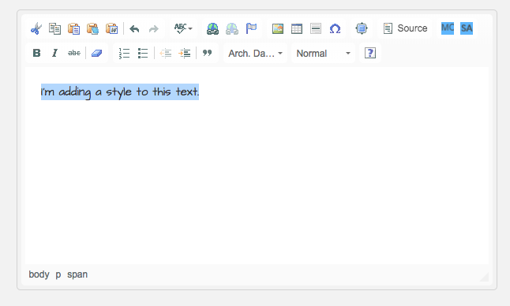

1. See the table below for a list of the available styles and what they do.

|  |  |
| --- | --- |
| Available styles | What they do |
| Automatic styling | Refresher Left pane and all Guided Practices use the “body style” LATO 16px black  Refresher Right Pane uses the “examples style”. Currently Tahoma 15px purple |
| Normal | Overrides the style and uses LATO 16px black |
| Marker | Highlights the text in yellow |
| Underline | Underlines the text |
| Examples | Used for examples in the Refresher left pane |
| Labels | Used for labels in the Refresher right pane. In the left pane and the Try its, use plain BOLD for the labels |
| Green check | Use to create the “correct” icon symbol |
| Orange times | Use to create the “incorrect” icon symbol |
| Title | Use to make a title for the refresher |
| Small examples | Makes the example text 14px instead of 15px |
| Double space | Makes the example text appear double-spaced (it’s set to 180%) |
| Arch. Daughter | Architect’s Daughter font. Used for handwriting |
| Screen Reader Blank | Use for tagging underscores so that screen readers read them as “blank” |
| Screen Reader Only | Use for designating text that should be hidden from the visual display, but read by screen readers. |

## Authoring for accessibility

See the document *Authoring for accessibility* in the **Content Authoring_overview, tryit, games** documentation directory for information about optimizing the JUICE content for accessibility.

### Using the “Screen Reader only” style effectively

When you use the *screen reader only* style,

* Prevent the screen reader from reading punctuation marks and hidden text by including a non-breaking space character after the displayed punctuation. Use Shift + spacebar to insert this character.
* Avoid hidden text and the next displayed word running together by including a comma and a non-breaking space after the hidden word as part of the screen reader only text.
* If the Screen Reader Only style follows displayed text or punctuation using the Marker style, the space following the punctuation should have the Marker style applied. If not, VoiceOver will read the punctuation as well as the screen reader only text.
* For an example of how to use this style go to /juice/author/refresher_widget/D1.10.Refresher_Overview_and_Try_It_test_plan

Use Shift + spacebar whenever you need to insert a non-breaking space character (&nbsp;)

## Guided Practice-specific features

The guided practice authoring template includes a few additional features not found in the Refresher authoring template.

1. The Guided Practice authoring template features a “Right Float Box” option. The content of the float box “floats” down the page and is always in view unless the box is marked hidden for a specific step.

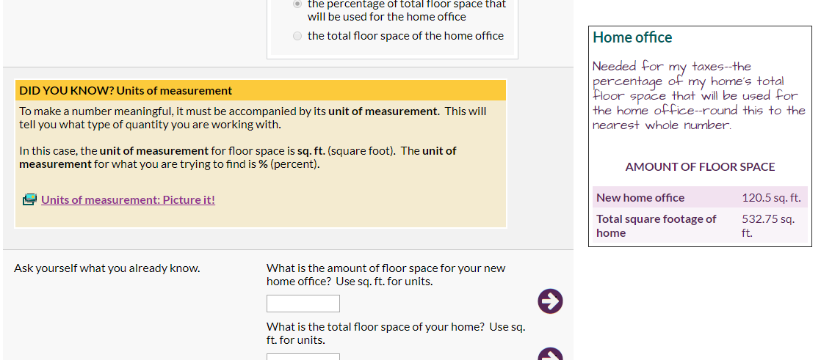

You can choose to hide the float box when a specific step is in view by choosing Hide Box:  
  
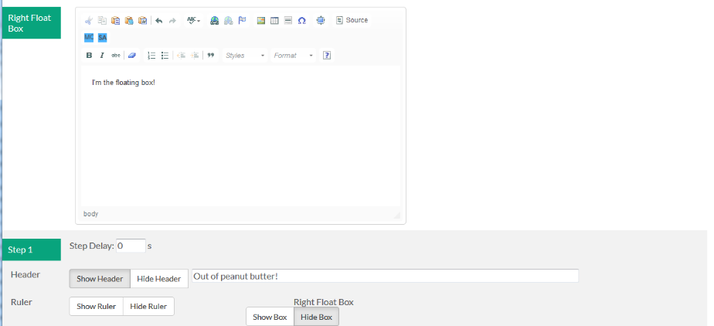

Show / Hide options.

This is where you author the contents of the float box.

1. “Show Ruler” adds a thin green (or blue) line to the top of the step. The ruler is used to group content within parts.

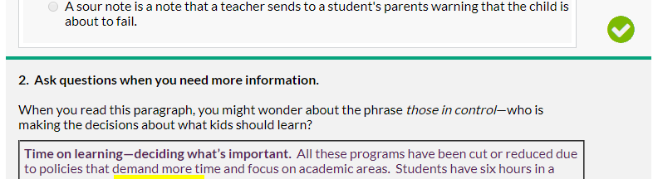

## Adding interactions to Guided Practices

You can add interactive questions to any step of a guided practice except the first. Interactions are usually in the right pane, but you can insert an interaction in the left pane if you hide the right pane. You may also insert interactions into tables.

To add an interaction, position your cursor where you would like the interaction, and then click either the blue MC or SA button in the panel’s toolbar.

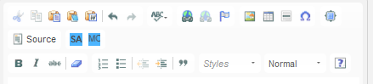

MC will open the “Multiple Choice” editor, which allows you to create standard multiple choice, multi-select, or fill-in interactions:

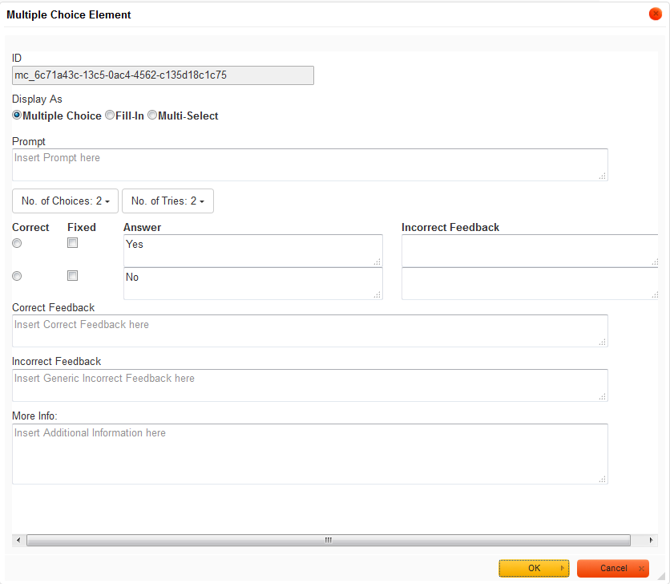

SA opens the “Short Answer” editor, which allows to create questions with an input field into which students type their answers:

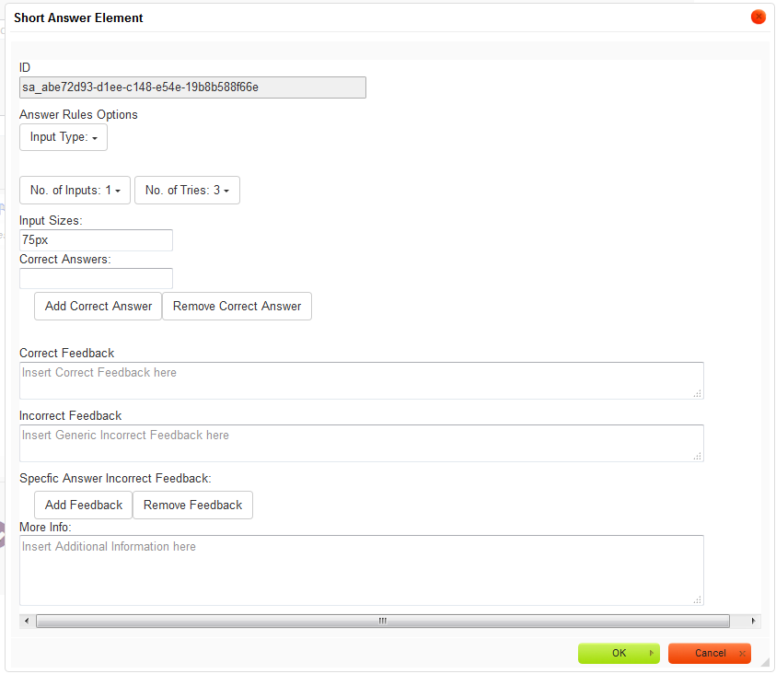

When you click OK on the interaction editor, a placeholder for the interaction will be inserted into the pane at the location or your cursor. The interactions themselves do not appear in the editor:

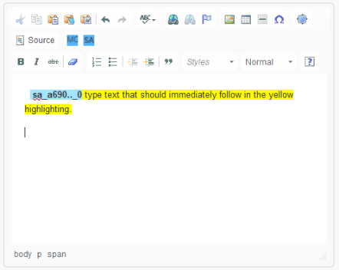

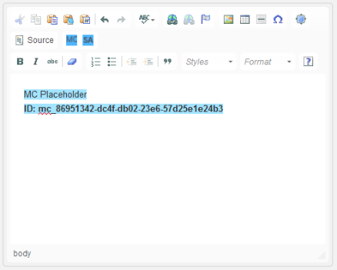

To add text after a short answer interaction on the same line, type it in the yellow highlighting.

To edit an existing interaction, click it to make sure it is selected (the selection will NOT be visible), then right-click it and choose Edit Multiple Choice or Edit Short Answer from the right-click menu.

You may move an interaction from one step to another by copying the source text. Click the panel’s Source button to open the Source Viewer, copy the desired text, click the Source button to open the Source Viewer on the target step, and paste.  
  
CAUTION: Do NOT re-use an interaction in the same guided practice; any edits made to the second instance of the interaction will overwrite the first instance and vice versa.

For more information on working with the short answer and multiple-choice editors, see the spreadsheet called *Refresher and Guided Practice authoring template instructions* in the **Content Authoring_overview, tryit, games** documentation directory.The 1st tab called “Authoring template basics” has sections on each type of answer editor and how you can use them to create different varieties of question interactions.

## Creating new challenge game files

New Challenge game files can be created using the same process as a Refresher or Guided Practice. Access your JUICE site with a role of “Admin” and open a blank game authoring template by modifying the end of the URL with:

/juice/author/[game_name]_widget/-

[game_name] is the name of one of the 11 different game types available. The editing template is different for each of the game types, so it is important that you know the type of game you want to create before opening and saving a new game template.

The available game widgets are:

balancer_widget

finders_keepers_widget

fix_it_widget

fridge_magnets_widget

highlighter_widget

perfect_word_widget

pick_and_stack_widget

puzzler_widget

quick_pick_widget

sorter_widget

stacker_widget

See the document *Game_type_summary_021518* in the **Content Authoring_overview, tryit, games** documentation directory for a complete summary of each game type. It describes how each of the game widgets can be used and their available customizations and answer types.

## Game authoring templates

Each game widget has its own authoring template. For information on editing these templates see the document, *Game authoring template instructions* in the **Content Authoring_overview, tryit, games** documentation directory.